­ GMI German-Malaysian Institute

DIPLOMA PROGRAMME
PRACTICAL TEST 1
Academic Period : July 2026

Program | : | CYBER SECURITY
Course | : | INTERNET OF THINGS
Code | : | CBS 2383
Duration | : | 1 HOUR 30 MINUTES
Total Marks | : | 50

GENERAL INSTRUCTIONS:

- Write down clearly (with capital letters) your name, trade, group and the date of examination at the bottom of this page.
- Do not open this question booklet until you are told to do so by the invigilator.
- Read the specific instructions and questions carefully before answering.

This paper consists of 7 printed pages including this page.

Student’s Name | : | 1. Abdul Hariz bin Mohd Sarnudin  2. Muhammad Danial bin Norhisam
Student’s I/D No. | : | 1. CBS24070208  2. CBS24070222
Semester/Trade/Group | : | SEM 5 / DCBS / CBS 1
Date | : | 13 / 10 / 2026

Practical Test 1
Raw Marks: |  |  | 50
Percentage (in Doc 01): |  |  | 15
 |  |  |  |  |  |  |  |  |  |  |  | PLO GMI
No | Assessment Criteria | Full Marks | Score  (if applicable) | Student's Marks | CLO | Level of Difficulty | DK. DP, NA (ETAC Programme Only) | Comments |  |  |  | PLO CBS  9 PLO - Start Intake July 2023 |  |  |  |  | PLO CBS  11 PLO - Start Intake July 2026
1 | Home Gateway Infrastructure & Security  • Wireless Security | 15 |  |  | 2 | P3 |  |  |  |  |  | 2 |  |  |  |  | 3
2 | Hardware Provisioning & Wireless Association | 20 |  |  | 2 | P3 |  |  |  |  |  | 2 |  |  |  |  | 3
3 | IoT Registration & Server Verification | 15 |  |  | 2 | P3 |  |  |  |  |  | 2 |  |  |  |  | 3
Total Full Marks |  | 50 | Total Student's Marks |  |  | 0
SUMMARY
Note:  FM - Full Marks,  StM - Student's Mark |  |  |  |  |  |  |  |  |  |  |  | PLO GMI
 |  |  |  |  |  |  |  |  |  |  |  | PLO CBS  9 PLO - Start Intake July 2023 |  |  |  |  | PLO CBS  11 PLO - Start Intake July 2026
Total |  |  |  |  |  |  |  | Raw Marks |  | Percentage |  |  | Raw Marks |  | Percentage |  |  | Raw Marks |  | Percentage
 |  |  |  |  |  |  | CLO | FM | StM | FM | StM | PLO | FM | StM | FM | StM | PLO | FM | StM | FM | StM
 |  |  |  |  |  |  | CLO 1 | 0 |  | 0.0 |  | PLO 3 | 0 |  | 0.0 |  | PLO 2 | 0 |  | 0.0
 |  |  |  |  |  |  | CLO 2 | 50 |  | 15.0 |  | PLO 2 | 50 |  | 15.0 |  | PLO 3 | 50 |  | 15.0
 |  |  |  |  |  |  | CLO 3 | 0 |  | 0.0 |  | PLO 4 | 0 |  | 0.0 |  | PLO 5 | 0 |  | 0.0
 |  |  |  |  |  |  | CLO 4 | 0 |  | 0.0 |  | #N/A | 0 |  | 0.0 |  | #N/A | 0 |  | 0.0
 |  |  |  |  |  |  | CLO 5 | 0 |  | 0.0 |  | #N/A | 0 |  | 0.0 |  | #N/A | 0 |  | 0.0
 |  |  |  |  |  |  | CLO 6 | 0 |  | 0.0 |  | #N/A | 0 |  | 0.0 |  | #N/A | 0 |  | 0.0
Total Marks |  |  |  |  |  |  |  | 50 |  | 15.0
Signature
 |  |  |  |  |  |  |  | ( )

NO. | CRITERIA | MARKS ALLOCATED | SCORED MARKS
1 | Home Gateway Infrastructure & Security  • Wireless Security (SmartHome_IoT / IoTPass2026)  • LAN DHCP Server (192.168.25.100 – .200) | 15 MARKS
2 | Hardware Provisioning & Wireless Association  • Device Placement (Admin Laptop, 4x IoT Endpoints)  • Wireless Module Installation & Association | 20 MARKS
3 | IoT Registration & Server Verification  • IoT Service Binding to Gateway Server (192.168.25.1)  • Verification via Admin Web Portal | 15 MARKS
 | TOTAL | 50 MARKS | MARKS

Scenario
A residential client has hired your cyber security team to deploy, configure, and secure a centralized Smart Home IoT infrastructure. Only the core central Home Gateway has been physically provisioned in the workspace.
Your team is required to deploy the client's requested wireless end-devices, establish secure WPA2-PSK wireless connectivity, configure dynamic IPv4 addressing services, and register all IoT endpoints to the central Home Gateway server for administrative management.

Addressing Table

Device Name | Placement Status | Interface Specs | Target Wireless SSID | IP Addressing Requirement | IoT Service Mode
Home Gateway | Pre-placed | Wireless / LAN | SmartHome_IoT | Static IP: 192.168.25.1/24 | Local IoT Server
Admin Laptop | Deploy Required | Wireless (WPC300N) | SmartHome_IoT | Dynamic (DHCP Pool) | Web Management Client
Motion Sensor | Deploy Required | Wireless Module | SmartHome_IoT | Dynamic (DHCP Pool) | Home Gateway Server
Ceiling Fan | Deploy Required | Wireless Module | SmartHome_IoT | Dynamic (DHCP Pool) | Home Gateway Server
Smart Door | Deploy Required | Wireless Module | SmartHome_IoT | Dynamic (DHCP Pool) | Home Gateway Server
Siren Alarm | Deploy Required | Wireless Module | SmartHome_IoT | Dynamic (DHCP Pool) | Home Gateway Server

Part 1: Hardware Provisioning & Topology Setup (20 Marks)
- Open Cisco Packet Tracer and locate the pre-placed Home Gateway.
- Deploy the following devices from the component library onto the logical workspace and rename them exactly as specified in the addressing matrix:
  - 1x Laptop --> rename to Admin Laptop
  - 1x Motion Detector --> rename to Motion Sensor
  - 1x Ceiling Fan --> keep name Ceiling Fan
  - 1x Door --> rename to Smart Door
  - 1x Siren --> rename to Siren Alarm
Student Evidence: Workspace Topology Capture
Paste a clear screenshot of your complete Packet Tracer physical/logical topology showing all 6 deployed devices below:

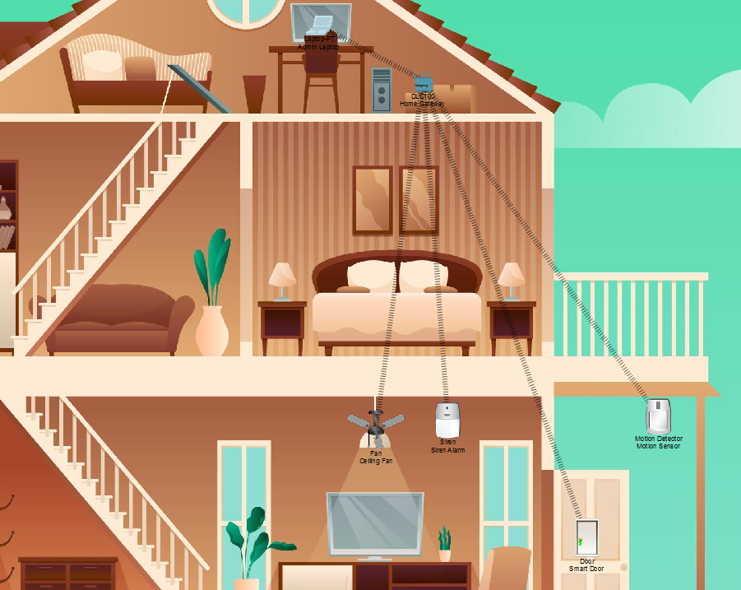

Part 2: Home Gateway Infrastructure & Security Configuration (15 Marks)
- Access the Home Gateway device and navigate to the GUI configuration tab.
- Configure the wireless security parameters as follows:
  - SSID: SmartHome_IoT
  - Security Type: WPA2-PSK
  - Encryption Passphrase: IoTPass2026
- Configure the LAN DHCP Server settings on the gateway:
  - Start IP Address: 192.168.25.100
  - Maximum Number of Users: 101 (Address range: 192.168.25.100 – 192.168.25.200)
  - DHCP Service: Enabled

Student Evidence: Home Gateway GUI Setup
Paste a screenshot showing the Home Gateway Wireless and DHCP configuration pages below:

- Home Gateway Wireless
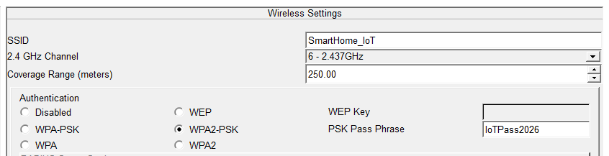

- LAN DHCP
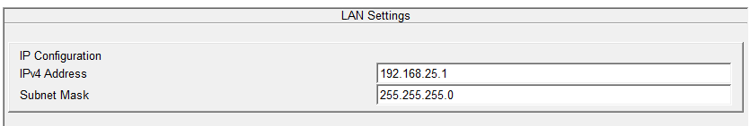

Part 3: Wireless Client Integration & Endpoint Connectivity
- Admin Laptop Setup:
  - Power down Admin Laptop, remove the default Ethernet module, install the WPC300N wireless module, and power the device back on.
  - Associate wirelessly with SSID SmartHome_IoT using passphrase IoTPass2026.
  - Confirm the laptop successfully receives an IP address dynamically via DHCP.

i. Configuring the Admin Laptop
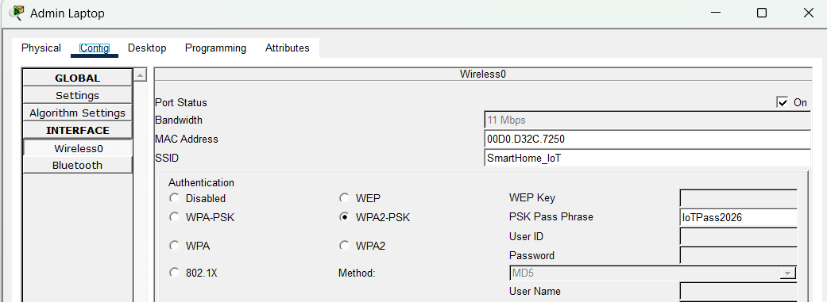

ii. Verifying connectivity, the DHCP server successfully assigned the IP address
‘192.168.25.103’
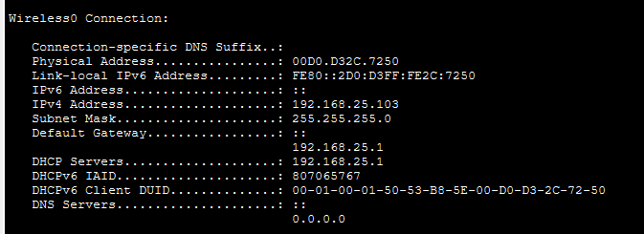

- IoT Endpoint Connectivity:
  - On each IoT device (Motion Sensor, Ceiling Fan, Smart Door, Siren Alarm), open Config > Wireless0.
  - Enter SSID SmartHome_IoT and WPA2-PSK passphrase IoTPass2026.
  - Set IP Configuration to DHCP on all devices.

Motion Sensor  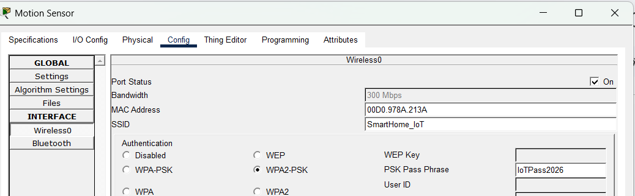 | Siren Alarm  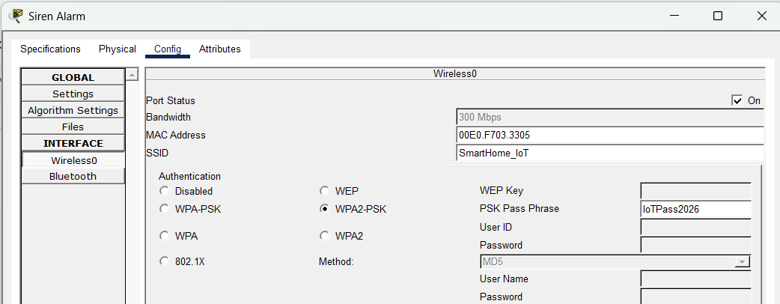
Ceiling Fan  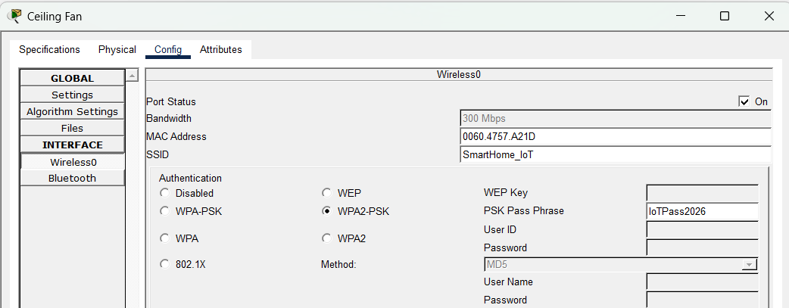 | Smart Door  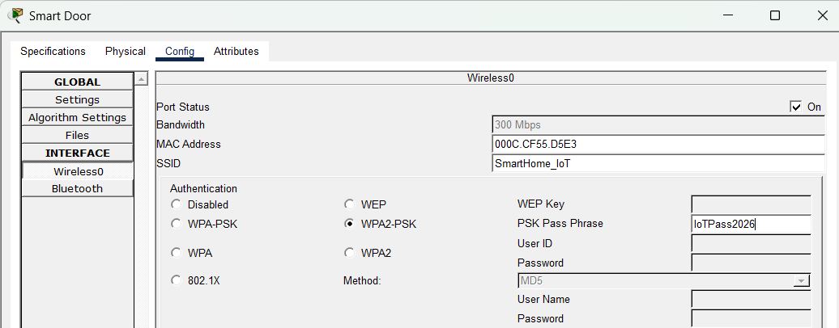

Device Name | Assigned IP Address | Subnet Mask | Wireless Link Status
Admin Laptop | 192.168.25.103 | 255.255.255.0 | Connected
Motion Sensor | 192.168.25.101 | 255.255.255.0 | Connected
Ceiling Fan | 192.168.25.102 | 255.255.255.0 | Connected
Smart Door | 192.168.25.104 | 255.255.255.0 | Connected
Siren Alarm | 192.168.25.105 | 255.255.255.0 | Connected

Part 4: Centralized IoT Registration & Server Verification (15 Marks)
- On each IoT end-device (Motion Sensor, Ceiling Fan, Smart Door, Siren Alarm):
  - Navigate to Config > Settings.
  - Under IoT Server, select Home Gateway.
- On Admin Laptop:
  - Open Desktop > Web Browser.
  - Navigate to [http://192.168.25.1](http://192.168.25.1).
  - Log in using administrator credentials (admin / admin).
  - Verify that all 4 IoT devices successfully register and appear online in the connected device dashboard.
Student Evidence: IoT Web Portal Dashboard
Paste a screenshot of the Admin Laptop web browser showing all 4 registered IoT devices listed under 192.168.25.1:

All the connected devices will be listed on the web portal once successfully login using the credentials admin:admin.

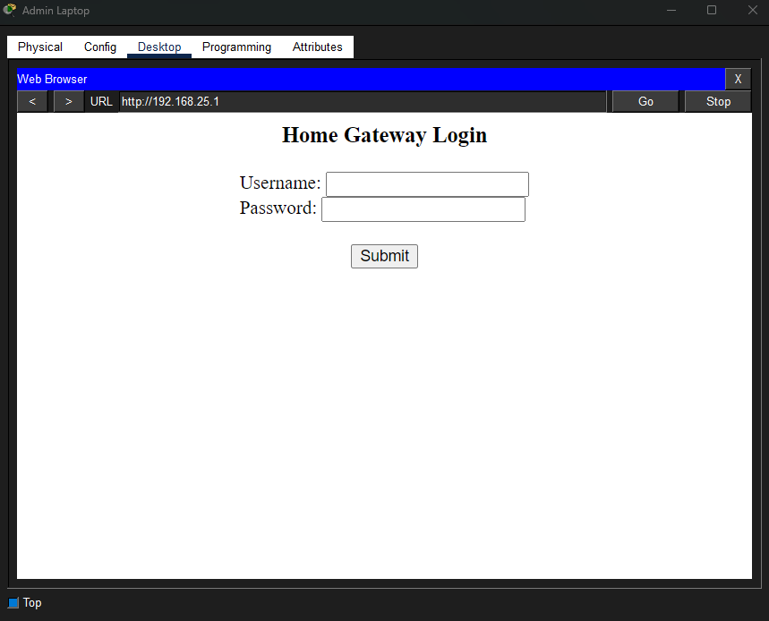 | 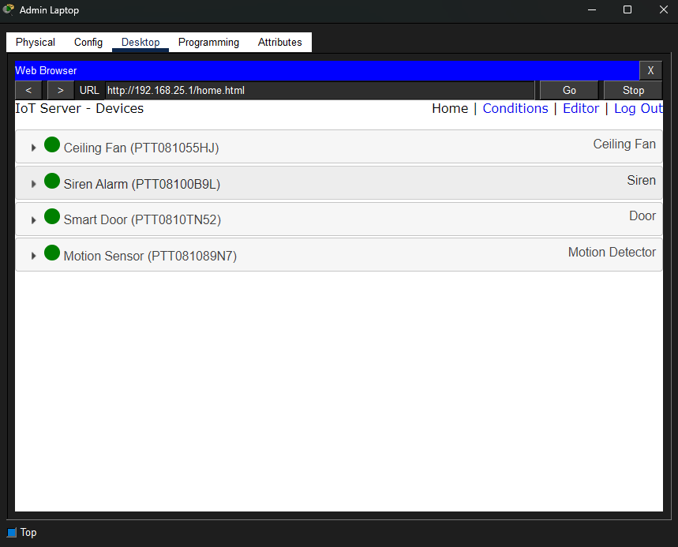

Part 5: Connectivity & ICMP Verification
- Open Command Prompt on Admin Laptop.
- Execute a ping command to test network reachability to the default gateway: ping 192.168.25.1.

Student Evidence: Ping Execution
Paste a screenshot of the Command Prompt output showing successful ICMP pings from Admin Laptop to Home Gateway:

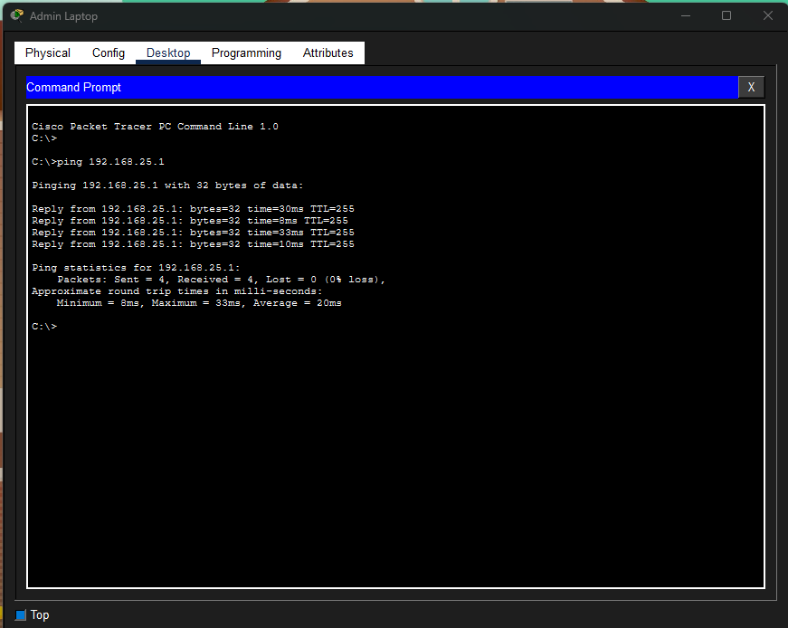

Part 6: Interpretation & Cyber Security Findings
Answer the following diagnostic questions concisely:
- Why is enforcing WPA2-PSK security essential on an IoT home network compared to leaving the wireless gateway open?
  - Student Answer: Enforcing WPA2-PSK encrypts wireless traffic to protect sensitive data from eavesdropping and prevents unauthorized users from joining the network to control smart home devices.
- What potential security risks occur if an IoT endpoint continues to use default administrative login credentials (admin / admin)?
  - Student Answer: Expose the endpoint to brute force attacks and botnet malware because once the credentials are compromised attackers can hijack smart device and other internal hosts.
- How does dynamic IP allocation via DHCP simplify IoT device provisioning, and why is central server registration necessary for automated smart home management?
  - Student Answer:
1. DHCP Simplifies by helping to eliminate manual IP assignment, prevents IP conflicts and allows rapid plug and play.
2. Central server registration provides a centralised control plane to monitors states, sensor readings, and actuator triggers from a single dashboard.

Part 7: Team Photo & Submission Requirements
- Team Photo / Selfie:
Take a selfie/photo of all team members completing this practical test and paste it below:


Submission Guidelines (Google Classroom)
- Submit 1 completed Lab Sheet Report in .docx or .pdf format per group.
- Submit 1 finalized Packet Tracer Activity file (.pka or .pkt) per group.
- Ensure all file naming conventions follow standard format: Practical_Test_1_CBS2383_[Group_Name].pka.

- END OF QUESTION PAPER -

